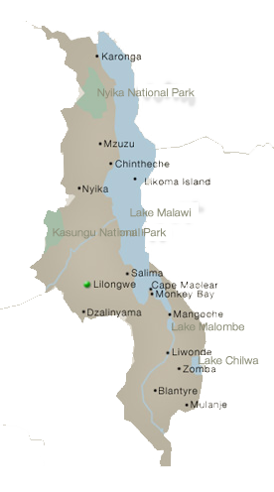

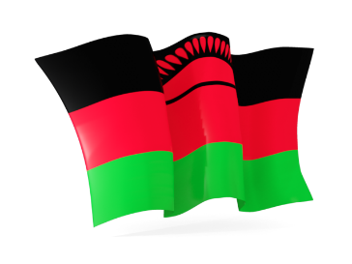**MALAWI**

**Mission Update**

**February 24, 2022**

Hello Everyone!

Just a quick update as it is the end of the month.

Everything in the ministry is going on well. In fact, we would very much appreciate your prayers as two more church plantings will be happening with Navincha and some of the faithful brothers and sisters from Bvumbwe. In the beginning of March, we will be planting a church in Mozambique down by Thekerani, and in the end of March we will be planting a church in Phalombe!! Finally! The people we ministered to there on our outreach trip have still been calling the brothers in Bvumbwe, and we are excited to officially add them to the ministry!

To help communication between us and the ministry, we will be purchasing a phone that can support internet for Navincha. Navincha will also have a schedule in which he will be checking up on all the churches. Praise God!

Sorry, there are no new pictures from that side for you.... hopefully this phone issue will help solve that problem, too.

Keep all of the members of the ministry in your prayers as they are recovering and rebuilding from Cyclone Ana. It was very destructive for the country.

Our church in Thekerani is still trying to solve the issue of where they should be meeting. They were gathering goods to build, but the cyclone changed that plan a bit for now. Pray they find a place to use soon. It will help the church there grow faster. And praise the Lord Chisomo has been preaching there quite a bit! We praise God for His faithfulness in his life. He will be going back to school in a few weeks.

Thank you for your faithful prayers, and for those that have been supporting us, may God increase you! Your funds are truly changing lives for the Kingdom.

I cannot believe my baby Benaiah will be one on February 26. Thank you for prayers for our family. Limbani’s visa papers are also being processed quickly! What a blessing.

We are staying busy here in the States and have started a youth group in a local church here! It is still small, but the youth involved already are excited and participating. We are encouraged. May you be, also!

God be with you all,

Leslie

